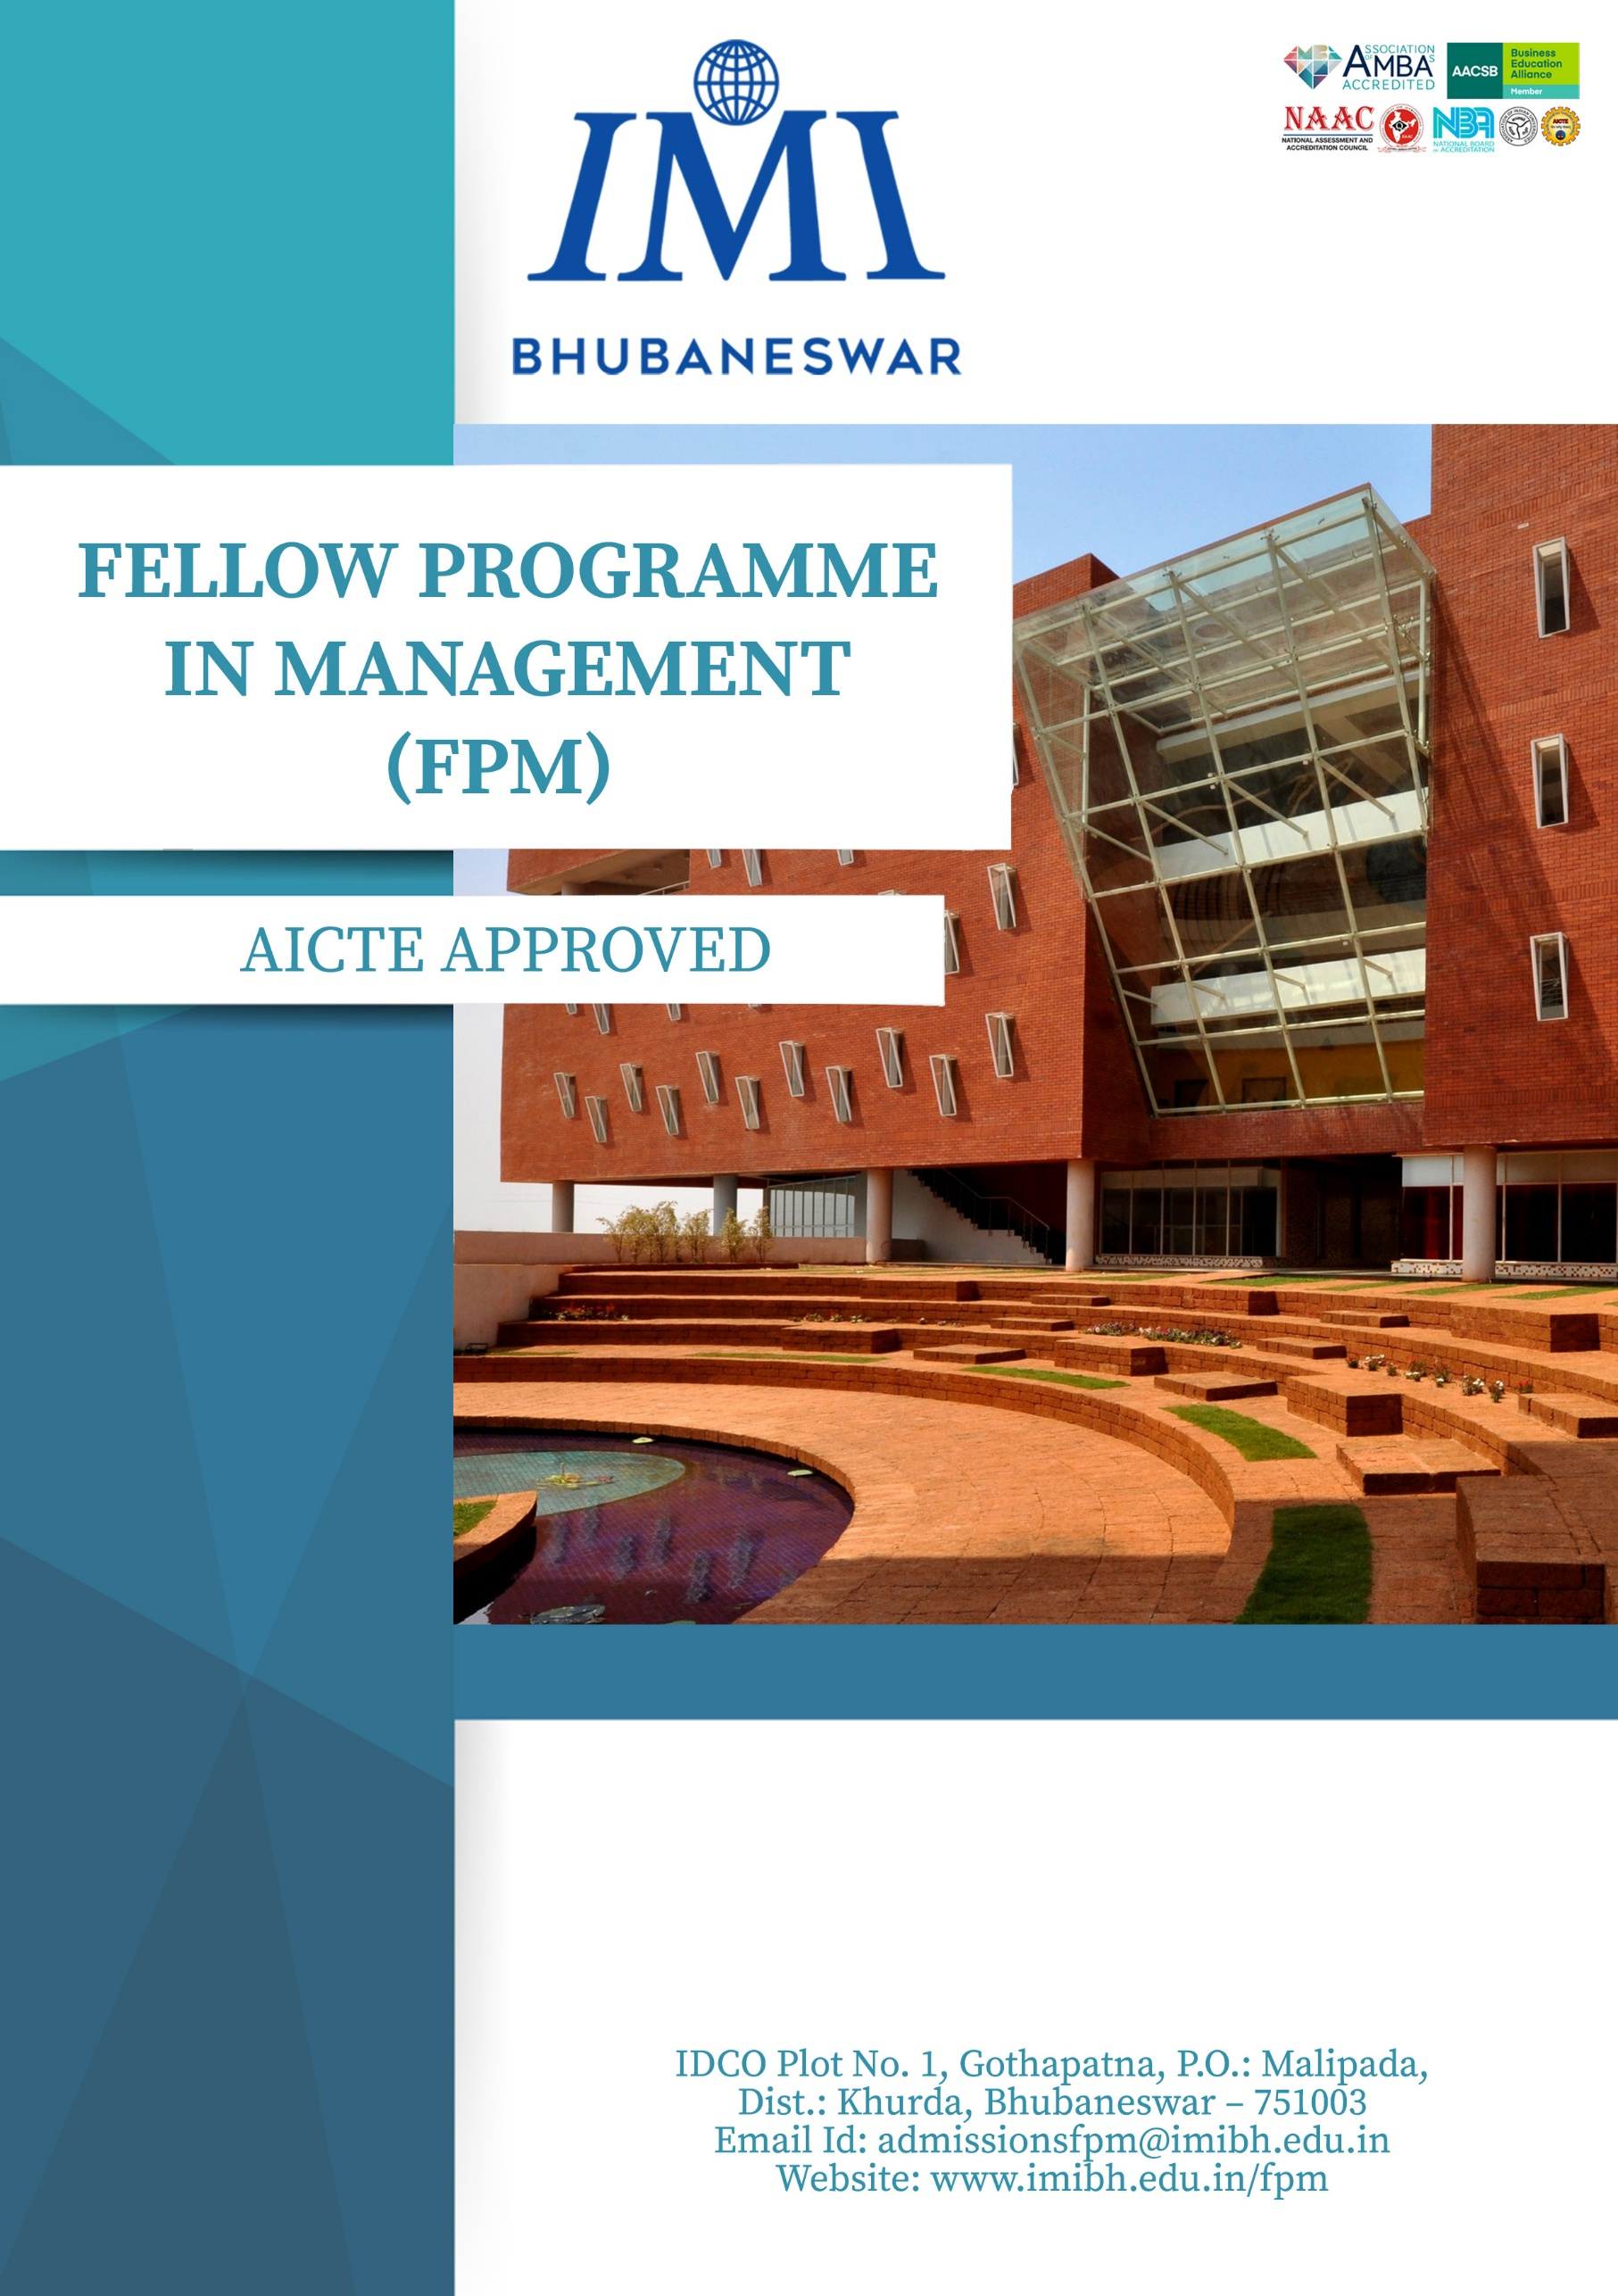


THE PROGRAMME

AICTE approved Fellow Programme in Management (FPM) at IMI Bhubaneswar is aimed at giving prospective scholars an academic space to challenge the conventional wisdom and encourage them to extend horizons of current thought into a new realm of knowledge and understanding. The FPM research scholars at IMI Bhubaneswar are expected to undertake a rigorous multidisciplinary approach and engage in original works of theoretical and application-oriented research with far reaching implications.

WHO SHOULD ATTEND

The FPM programme has been designed to cater to the scholarly needs of individuals who are willing to pursue rigorous research work at the doctoral level. These may include:

- Faculty members
- Executives from the government and private sector
- Researchers
- Postgraduates
- MPhil students

SALIENT FEATURES OF THE PROGRAMME

- Attractive Stipend:
- Rs. 50,000/month stipend from beginning of the course work up to the submission of their thesis/completion within four years from the date of admission

- Additional Financial Support:
- Contingency Grant: Rs. 80,000
- Conference Grant: Rs. 1,50,000

- Top 2% global researchers as faculty
- Six research focused specializations
- State-of-the-art infrastructure and classrooms
- IT and Library ecosystem with advance research platforms &amp; databases
- Scholar-Friendly leave policy

AREAS OF SPECIALIZATION

- Economics and Public Policy
- Entrepreneurship and Innovation
- Finance and Accounting
- Information Management and Analytics
- Marketing Management
- Operations Management and Quantitative Techniques
- Organizational Behaviour and Human Resource Management
- Strategy and General Management

PROGRAMME OBJECTIVES

The programme aims to fulfil the following objectives:
- To generate conceptual and empirical knowledge in the field of business
management
- To disseminate knowledge regarding rigorous interdisciplinary research practices
- To promote ethical research practices
- To extend the horizon of knowledge in various domains of business management
- To promote research that leads to actionable decisions by the industry
PROGRAMME DURATION
The FPM at IMI Bhubaneswar is a four-year programme which can be extendable by 1 year. However, in case of exceptional circumstances, the programme may further be extended twice by 1 year duration, subject to approval by competent authorities.
PROGRAMME STRUCTURE
The programme is offered in the following two modes:
- Residential programme
- Non-residential programme
Students under residential programme will be required to be present physically on campus throughout the programme.
The programme is divided into two phases. The first phase requires the scholar to undertake course work. On completion of the course work, the students will be required to take a Comprehensive Examination (CE). The CE is based on a scholar’s chosen area of interest. The purpose of CE is to provide scholars with an opportunity to identify their area of research interest and build sound background knowledge for their dissertations. During the second phase, scholars are expected to work on their doctoral thesis. The award of FPM at the end of the second phase requires the scholar to prepare a thesis proposal, pursue research based on the approved proposal under the guidance of the faculty supervisor, and finally, defend the thesis before the research committee.

COURSE STRUCTURE & CURRICULUM
The subjects to be studied by the students during the coursework are as follows:

Structure of Coursework

Term-I | Term-II | Term-III
Quantitative Research Methodology (3 credits) | Area Core-1 (3 credits) | Area Elective 1 (3 credits)
Qualitative Research Methodology (3 credits) | Area Core-2 - Advanced Research Methods – Area specific (3 credits) | Area Elective 2 (3 credits)
Academic & Technical Writing (3 credits) | Teaching pedagogy (1.5 credits) | Cross-elective from other areas (3 credits)
 | Research and Publication Ethics (RPE) (1.5 credits)
Credits: 9 | Credits: 9 | Credits: 9
 | Seminar Paper (3 credits)**
TOTAL CREDITS: 30

** Seminar paper should be in line with the research work of the candidate and should focus on the initial research framework. The modus operands of Seminar Paper will be provided in the Area Elective Courses in Term III. The student will be required to take four electives from his/her area of specialization. Instead of opting for an elective course in the area, a student can also work on a Course of Independent Study (CIS) under a faculty member. If a student decides to work on the CIS, the same will be considered an elective course.
The students will be required to prepare the seminar paper and the paper based on the review of literature as a part of their coursework. These papers would be presented in the in-house monthly research seminar and should be of publishable quality. The student is required to appear for the Comprehensive Exam (CE) at the end of the course, and on successful completion, they will commence work on their thesis.
The tentative list of area wise electives is given below:
AREA WISE ELECTIVE COURSES
Economics and Public Policy  Energy Economics and Policy  Planning, Implementation and Evaluation of Public Policy  Geopolitical Uncertainty and International Trade  Indian Economy: Sectoral Dynamics  Inclusive Growth and Development  Economics of Public Finance  Open Economy and Macroeconomics  Blue Economy and Global Trade | Entrepreneurship and Innovation  Entrepreneurship and Innovation  Design Thinking  New Venture Creation  Managing Family Businesses  Entrepreneurial Finance  Entrepreneurial Marketing  Managing People and Teams in Startup Organizations  Technology and Management for Startups
Finance and Accounting  Quantitative Research Methods in Finance  Asset Pricing  Algorithmic Finance and Trade  High-Frequency Finance  Computational Finance  Contemporary Research in Management Accounting and Financial Reporting  Qualitative Research in Accounting and Finance  Financial Analytics  Microfinance: Theory and Practice  Green and Sustainable Finance | Information Management and Analytics  Advanced Business Analytics  Block Chain and Cyber Security  Data Visualization & Dashboard  Data Pre-Processing and Management using SQL, R and Python  Digital Marketing  Applied Machine Learning  Data Modelling through Advanced Excel and VBA
Marketing Management  Principles of Marketing  Consumer Research  Marketing Theory  Product and Brand Management  Services Marketing  Digital Marketing | Operations Management and Quantitative Techniques  Advanced Service Operations Management  Sustainable Supply Chain  Advanced Supply Chain Management  Inventory Theory  Supply Chain Coordination and Contracts
Organizational Behaviour and Human Resource Management  Theory and Research in Individual Dynamics at Workplace  Leadership and Interpersonal Group Processes  Advances in HRM  Organizational Theory and Design  Diversity Management | Strategy and General Management  Entrepreneurship  CSR & Sustainability  Corporate Governance  Theories of the Firm
AREAS OF RESEARCH
The faculty at IMI Bhubaneswar guides the FPM students and provides them with an opportunity to do research on cutting edge and contemporary topics like:
- Business Analytics
- Buyer-supplier relationship
- Circular economy
- Customer sentiment analysis using unstructured data
- Digital Marketing
- Diversity and inclusion
- Entrepreneurship and Crowdfunding
- Fixed income analytics
- Green Financing
- Green innovation
- Impact of digital transformation on the supply chain
- Impact of Technology in HRM
- Industry 4.0 and the manufacturing ecosystem
- Social media analytics for superior customer experience
- Social Network Analysis
- Supply chain risk management
- Sustainability
- Text Analysis of Financial Reports
- Value co-creation
FEE STRUCTURE
Residential Programme:
Full Time Students
 | Academic | Text/Reading | Student | Library | IT Fee | Tuition | Registration | Alumni- Life | Refundable Security
 | Fee | Material | Welfare | Fee | (e) | Fee | Fee | Membership | Deposit*
 | (a) | (b) | (c) | (d) |  | (a+b+c+d+e)
1st | Academic Fee waived off
Instalment |  |  |  |  |  |  | 25000 | 10000 | 15000
2nd
Instalment |  |  |  |  |  |  | .. | .. | ..
3rd
Instalment |  |  |  |  |  |  | .. | .. | ..
4th
Instalment |  |  |  |  |  |  | .. | .. | ..
Total |  |  |  |  |  |  | 25000 | 10000 | 15000
Non-Residential Programme:
Corporate Executives
 | Academic | Text/Reading | Student | Library | IT Fee | Tuition | Registration | Alumni- Life | Refundable Security
 | Fee | Material | Welfare | Fee | (e) | Fee | Fee | Membership | Deposit*
 | (a) | (b) | (c) | (d) |  | (a+b+c+d+e)
1st
Instalment | 120000 | 9000 | 4500 | 8000 | 8500 | 150000 | 25000 | 10000 | 15000
2nd
Instalment | 120000 | 9000 | 4500 | 8000 | 8500 | 150000 | .. | .. | ..
3rd
Instalment | 120000 | 9000 | 4500 | 8000 | 8500 | 150000 | .. | .. | ..
4th | 120000 | 9000 | 4500 | 8000 | 8500 | 150000 | .. | .. | ..
Instalment
Total | 480000 | 36000 | 18000 | 32000 | 34000 | 600000 | 25000 | 10000 | 15000
Faculty and Academicians
 | Academic | Text/Reading | Student | Library | IT Fee | Tuition | Registration | Alumni- Life | Refundable Security
 | Fee | Material | Welfare | Fee | (e) | Fee | Fee | Membership | Deposit*
 | (a) | (b) | (c) | (d) |  | (a+b+c+d+e)
1st
Instalment | 70000 | 9000 | 4500 | 8000 | 8500 | 100000 | 25000 | 10000 | 15000
2nd
Instalment | 70000 | 9000 | 4500 | 8000 | 8500 | 100000 | .. | .. | ..
3rd
Instalment | 70000 | 9000 | 4500 | 8000 | 8500 | 100000 | .. | .. | ..
4th | 70000 | 9000 | 4500 | 8000 | 8500 | 100000 | .. | .. | ..
Instalment
Total | 280000 | 36000 | 18000 | 32000 | 34000 | 400000 | 25000 | 10000 | 15000
Note 1*: The security deposit is refundable subject to obtaining clearance against all dues and damages, if any, to the institute's properties/assets.
Note 2: Each candidate needs to adhere to the payment schedule. Late fee payments are accepted only in exceptional cases (with prior approval), with a daily penalty of Rs. 500 per day from the scheduled date.
FEE WAIVERS & OTHER FINANCIAL SUPPORT FOR RESIDENTIAL PROGRAMME
FPM Scholars will get a stipend of Rs. 50,000/month stipend from beginning of the course work up to the submission of their thesis/completion within four years from the date of admission. The stipend is conditional on the approval of the monthly progress report of the research scholar by the supervisor / Thesis Advisory Committee. FPM Scholars must be physically present on campus for both their coursework and doctoral research to be eligible for stipends. The FPM Scholar will also contribute as a Teaching/Research Assistant at IMI Bhubaneswar. Over and above the monthly stipend, a contingency grant of Rs. 20,000 per year [equivalent to a maximum of Rs. 80,000 for a total of 4 years] will be provided to the scholars, to be utilised for stationary, books, accessing / downloading research papers/journals/industry reports, databases, publication or editing charges for research papers, thesis, and the like. Scholars are also entitled to get up to Rs. 1,50,000/-
PAYMENT DETAILS
The details for NEFT/RTGS transfer are:
International Management Institute, Bhubaneswar
HDFC Bank Ltd., Account No. 50100208031034,
IFSC- 50100208031034, Khandagiri, Bhubaneswar

Please email the payment details at admissionsfpm@imibh.edu.in providing the following details: Name of the Applicant, Bank Name, UTR Number, Date of Transfer, Amount of Transfer.
ELIGIBILITY
- Master’s Degree or equivalent in Engineering and Technology/ Management/ Economics/ Social Science/ Biological Science/ Pure Science/ Commerce/ Humanities with FIRST CLASS shall be considered for admission to Fellow Programme.

- Those appearing for their final examination in the respective discipline can also apply. Such students, if selected, shall be provisionally admitted provided they complete all requirements in obtaining their master’s degree before 30th December of the year of admission. The admission of these candidates shall remain provisional until they produce the mark sheet proving that they satisfy the afore mentioned eligibility criteria. The deadline for submitting the final year mark sheet is 31st December.

ADMISSION PROCEDURE

Fill online application form available on https://admission.imi.edu/fpm-bhubaneswar

SELECTION PROCESS

- IMI Bhubaneswar Research Aptitude Test
- Essay Writing
- Personal Interview
Candidates having valid CAT/GMAT/GRE/UGC NET/CSIR/NBHM scores will be exempted from taking IMI Bhubaneswar Research Aptitude Test.

CONTACT DETAILS
IMI, Bhubaneswar
IDCO Plot No.1, Gothapatna, Malipada, Bhubaneswar-751003; Odisha.
Cell: +91-6370954600/7789022222
Email Id: admissionsfpm@imibh.edu.in
Website: www.imibh.edu.in/fpm

CHAIRPERSON FPM
Dr. Sourabh Sharma, Professor, IMI Bhubaneswar, Email: sourabh@imibh.edu.in

